**Program Specification:  
a Quiz game in Python**

**Specifying the program objectives**

**The goal is to create a text-based Quiz game using Python programming language.** A quiz is a „question and answer” game in which knowledge or estimation questions are to be answered as correctly as possible. Knowledge or skills can be tested in a creative and playful way. Sometimes it is lexical, other times it relies on other skills.

This quiz game tries to entertain the players and test their knowledge in different topics.

**Specifying the desired output/INPUT**

**The program is supposed to provide questions with answers as possible alternatives in a graphical user interface, which consists of a regular dialog box window and control elements. The questions and answers are stored outside of the program, but the program is able to read them and show them to the user transported by a data storage format files such as \**.csv, *.json.***

**For answering the questions and create the connection between the game and user, GUI must include the question and the alternatives to be selected, otherwise graphical control elements such as buttons that allow the user to select the desired answer and submit it in order to proceed question-by-question. Sample window arrangement is shown on Figure 1 for the preliminary idea.**

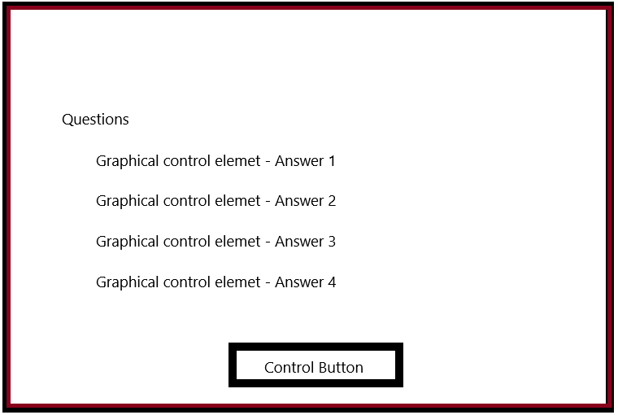

Feedback field

„Hint” button

Figure 1 – Sketch-level window of question and answers arrangement

**The gameflow starts with a selection process where the user is prompted to choose the desired topic of questions (e.g.: sport, music etc.). During the game the user can achieve bonus question by choosing the correct answers in a specific row or get a secret password to unlock that. Furthermore the program is supposed to offer a „hint” button and/or limit the time to complete the actual question, tell whether the answer is right or not, count the player’s result and display them, otherwise store the previous results in a ranking list is also the part of the broad idea.**